RES.25-XXX APPROVING AND UPDATING A SPONSORSHIP AND COMMERCIAL ADVERTISING POLICY FOR ORANGE TOWNSHIP
Mr. Ringle moved for the adoption of the following Resolution:

WHEREAS, pursuant to Ohio Revised Code Section 503.70, the Board of Trustees (the “Board”) may, by resolution, authorize the use of commercial advertising on the Township’s website, provided that the use of commercial advertising must comply with all state and federal law, including Section 9.03 of the O.R.C., and any applicable federal regulations or guidelines; and

WHEREAS, pursuant to O.R.C. 503.70(C), the resolution shall specify the manner of making requests for proposals that identify advertisers whose advertisements will meet the criteria specified in the request for proposal; and

WHEREAS, the Board desires to, and believes that it is in the best interest of the Township, to establish criteria for commercial advertising and sponsorships for Township events and on its website as set forth herein., the Board of Trustees (the “Board”) of Orange Township, Delaware County, Ohio (the “Township”).

RESOLUTION
RESOLVED, that the Board hereby authorizes the issuance of sponsorships for Township events and activities, and advertising on the Orange Township Website. The use of commercial advertising shall comply with state and federal law, and any general regulations or guidelines on the use of commercial advertising on .gov internet domain or other federal controlled domains.
BE IT FURTHER RESOLVED, that the Board adopts the levels of sponsorship opportunities attached hereto as Attachment 1, and incorporated herein by this reference. Any funds collected pursuant to Attachment 1 shall be deposited within the Township General Fund.
BE IT FURTHER RESOLVED, that the Board authorizes the Township Administrator to enter into a Sponsorship and Website Advertising Contract with any vendor meeting the qualifications set forth within Attachment 2
BE IT FURTHER RESOLVED, that the Board finds and determines that all formal actions of this Board concerning and relating to the passage of this Resolution were taken in an open meeting of this Board and that all deliberations of this Board that resulted in such formal action were in meetings open to the public, in compliance with all legal requirements.
BE IT FURTHER RESOLVED, that this Resolution supersedes and replaces the existing sponsorship and advertising policy.
BE IT FURTHER RESOLVED, that this Resolution shall be in full force and effect immediately upon its adoption.
Seconded by M.
VOTE: Ringle- Knapp - Fouss –

Seconded by M.
VOTE: Ringle - Fouss - Knapp -

Certify and Attest: __________________________________________
Donna Batten, Township Fiscal Officer
Orange Township, Delaware County, Ohio
Sponsorship Guidelines
Objective – To create sponsorship opportunities and obtain advertising space on the Orange Township Website and other promotional marketing items in exchange for funds to be deposited within the Orange Township General Fund or in-kind contributions.
In addition, for the exchange for supporting the Township, the company will have advertising as outlined in Attachment 1 “Levels of Sponsorships”
Attached hereto is a non-comprehensive list of sponsorship and advertising opportunities.
Restrictions:
No advertisements or sponsorships that violate the restrictions of O.R.C. 9.03 shall be excepted. This includes any advertisements that does any of the following:
- Contains defamatory, libelous, or obscene matter;
- Promotes alcoholic beverages, cigarettes or other tobacco products, or any illegal product, service, or activity;
- Promotes illegal discrimination on the basis of race, color, religion, national origin, disability, age, or ancestry;
- Supports or opposes any labor organization or any action by, on behalf of, or against any labor organization;
- Supports or opposes the nomination or election of a candidate for public office, the investigation, prosecution, or recall of a public official, or the passage of a levy or bond issue.

All advertisements shall comply with state and federal law, including O.R.C. 9.03, and any federal regulations or guidelines on the use of commercial advertising on the .gov internet domain or other federally controlled public domains.

Sponsorship Opportunity Specifications

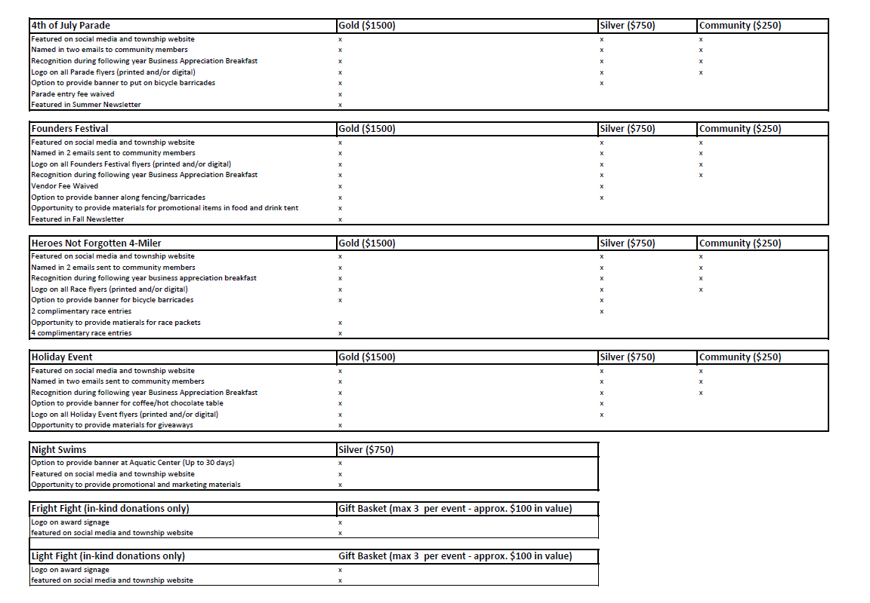
“In-Kind” or Other Sponsorships - The Township Administrator is authorized and empowered to accept sponsorship offers other than the items set forth herein so long as the sponsorship does not exceed $2,499 or the fair market value for in-kind goods or other items of value. As part of accepting and receiving a sponsorship offer, the Township Administrator is further empowered and authorized to provide sponsorship and advertising opportunities consistent with the aforementioned categories, and/or other sponsorship benefits as the Township Administrator may determine to be appropriate based upon the sponsorship offer.
ORANGE TOWNSHIP SPONSORSHIP AND WEBSITE ADVERTISING CONTRACT
Orange Township Website and Sponsor Advertising Contract
Sponsorships and Ads will be published on a first-come, first served basis. Payment is required prior to securing the sponsorship or publication date. Advertisements published on the Orange Township Website or displayed at Orange Township events in no way constitute an endorsement of a product or service by the Orange Township Board of Trustees. The Orange Township Board of Trustees reserves the right to reject any sponsorships or advertisements for publication. Neither the Orange Township Board of Trustees nor its employees are responsible for loss of income, real or implied as a result of non-publication.
------ --------------------------------------------------------------
Business Name:--------------------------------
Contact Name: ______________________________ _
Address:--------------------------------
City/State/Zip: __________________________ _
Phone: _______________ Fax: _________________ _
E-Mail: ____________ _
Level of Sponsorship:
Amount:
Event:
--------------------------------------------------------------------
I hereby authorize the commitment of a sponsorship or advertisement and agree to pay the amount listed upon receipt of an invoice prior to printing and distribution of the sponsorship or advertisement as outlined in this contract. The Township retains full authority on determining the length of a sponsorship or advertisement’s placement on the Township’s website and/or events.

Authorized Agent Date
---------------------------------------------------------- Please return this form to: Orange Township Board of Trustees
Attn: ____________________
_________________________
_________________________
If you have any question or need additional information, please feel free to contact _____________ at (___) ________________.
Disclaimer: By signing this I, the participant, agree to waive any present or future claims, and will release and hold harmless the Township from any and all liability as a result of any injuries/and or damages suffered or incurred while attending Township-sponsored events or on the premises belonging to the Township, for any reason.

