The electronic recordings of this meeting serve as the official meeting minutes.
A full and accurate account of this meeting’s audio and video can be found at www.orangetwp.org

Mr. Ringle to call the meeting to order at 3:00 p.m.

PRESENT: Michael Ringle, Chair
Erica Fouss, Vice Chair
Lisa Knapp, Trustee
Donna Batten, Fiscal Officer

ALSO PRESENT: Michele Boni, Township Administrator
Valerie Bunting, Administrative Manager
Nathan McNeil, Fire Chief
Silas Bowers, Director of Operations
Mike Kremnitzer, Senior Human Resources Manager
Robin Duffee, Director of Development and Zoning
Sydney Herbert, Communications and Special Events Manager

1) IN THE MATTER OF APPROVING THE CONSENT AGENDA FOR THE REGULAR MEETING HELD ON MARCH 19, 2025:
It was moved by Mr. Ringle to approve the consent agenda for the Regular Meeting held on March 19, 2025.

Seconded by Mrs. Fouss
VOTE: Ringle – Yes Fouss – Yes Knapp – Yes

NOW, THEREFORE, BE IT RESOLVED THAT THE BOARD HEREBY APPROVES THE FOLLOWING CONSENT AGENDA ITEMS FOUND IN LINE-ITEM A)

- RES.25-089 APPROVING THE ELECTRONIC RECORD OF THE PROCEEDINGS FROM THE ZONING HEARING HELD ON MARCH 4, 2025, REGULAR MEETING HELD ON MARCH 5, 2025 AND THE SPECIAL MEETING HELD ON MARCH 7, 2025
Motion by Mr. Ringle

WHEREAS, the Board of Trustees for Orange Township, Delaware County, Ohio (the “Board”) met in regular session on March 4, 2025, March 5, 2025, and special session on March 7, 2025.

WHEREAS, the Fiscal Officer has certified, pursuant to section 305.11 of the Ohio Revised Code, that the entire record of the proceedings at that meeting is completely and accurately captured in the electronic record of those proceedings;

NOW, THEREFORE, BE IT RESOLVED that the Board hereby approves the electronic record of proceedings at the zoning hearing held on March 4, 2025, regular meeting held on March 5, 2025, and special meeting held on March 7, 2025.

- RES.25-090 APPROVING PURCHASE ORDERS, THEN AND NOW PURCHASE ORDERS, AND BLANKET PURCHASE ORDERS AS LISTED:

Vendor Description Account Amount
Pro Power, LLC | Autonomous Mowers | Parks | $27,099.96
Decker Construction | Curb Highmeadows Dr. | Roads | $90,000.00
Decker Construction | Curb & Ramps | Roads | $74,345.90
Even Flo | North Orange Irrigation | Parks | $45,500.00

RES.25-091 SCHEDULE HEARING DATE FOR ZON-25-01, STUGOTS ITALIAN SAUSAGE RESTAURANT
Motion by Mr. Ringle to set hearing date for ZON-25-01, Stugots Italian Sausage, on April 16, 2025at 4:30 p.m. at Township Hall.

Seconded by Ms. Knapp
VOTE: Ringle – Yes Fouss – Yes Knapp – Yes

RES.25-092 AUTHORIZING THE POSTING OF THE JOB ANNOUNCEMENT FOR TWO (2) SEASONAL PUBLIC WORKS LABORER POSITION VACANCIES
Mr. Ringle moved the adoption of the following resolution:

BE IT RESOLVED that the non-exempt, non-bargaining unit position of Seasonal Public Works Laborer is hereby created.

BE IT FURTHER RESOLVED that the Seasonal Public Works Laborers shall serve under the direction of the Director of Operations as well as the Board of Township Trustees.

BE IT FURTHER RESOLVED that the Seasonal Public Works Laborers shall have those qualifications, requirements, duties and responsibilities, and serve under those terms and provisions, stated in the position description presented to the Board.

BE IT FURTHER RESOLVED that the position description is presented for informational purposes only and can be changed at any time by the Board, with or without notice.

BE IT FURTHER RESOLVED that, unless otherwise provided by the Board, appointment to this position shall be contingent upon the applicant's satisfactory completion of a drug screening and background investigation.

Seconded by Mrs. Fouss
VOTE: Ringle – Yes Fouss – Yes Knapp – Yes

RES.25-093 AUTHORIZING THE POSTING OF THE JOB ANNOUNCEMENT FOR SEASONAL PARKS, MAINTENANCE, AND FACILITIES LABORER POSITION VACANCY
Mr. Ringle moved the adoption of the following resolution:

BE IT RESOLVED that the non-exempt, non-bargaining unit position of Seasonal Parks, Maintenance, and Facilities Laborer is hereby created.

BE IT FURTHER RESOLVED that the Seasonal Parks, Maintenance, and Facilities Laborer shall serve under the direction of the Director of Operations as well as the Board of Township Trustees.

BE IT FURTHER RESOLVED that the Seasonal Parks, Maintenance, and Facilities Laborer shall have those qualifications, requirements, duties and responsibilities, and serve under those terms and provisions, stated in the position description presented to the Board.

BE IT FURTHER RESOLVED that the position description is presented for informational purposes only and can be changed at any time by the Board, with or without notice.

BE IT FURTHER RESOLVED that, unless otherwise provided by the Board, appointment to this position shall be contingent upon the applicant's satisfactory completion of a drug screening and background investigation.

Seconded by Ms. Knapp
VOTE: Ringle – Yes Fouss – Yes Knapp – Yes

RES.25-094 REVIEW OF THE FEBRUARY BANK RECONCILIATION AND FINANCIAL REPORTS
Motion by Mr. Ringle

 | AS OF 02/28/2025
 | Fund Balance | YTD Revenue** | YTD Expenses** | Current Reserve for Encumbrance
General | $12,113,149 | $263,013 | $524,435 | $1,837,892
Roads | $2,935,775 | $0 | $230,285 | $13,250
Fire | $6,531,148 | $45,382 | $1,524,945 | $2,910,737
Parks | $4,143,445 | $26,396 | $139,190 | $2,718,072
Other funds | $2,671,156 | $258,051 | $102,960 | $366,276
TOTAL | $28,394,673 | $592,841 | $2,521,814 | $7,846,227
 | ** does not include transfers and advances

Copies of reports provided for each Trustee: Fund Summary & Status, Appropriation Status, and Revenue Summary as of February 28, 2025.

Seconded by Mrs. Fouss
VOTE: Ringle – Yes Fouss – Yes Knapp – Yes

RES.25-095 REVISING AND/OR INCREASING PERMANENT APPROPRIATIONS ESTABLISHED IN RES.24-340
Mr. Ringle moved the adoption of the following Resolution:

WHEREAS the Board of Trustees for Orange Township, Delaware County, Ohio (the “Board”) met in regular sessions on December 4, 2024 and approved Resolution 24-340;

WHEREAS total appropriations of $30,247,690.00 included $0.59 more than was available for County TIF Fund because of rounding;

BE IT RESOLVED that the appropriations for the fiscal year ending December 31, 2025, as made at the Trustee Meeting on December 4,2024, in Res.24-340 are decreased by $0.59 with specific changes as follows:

Purposes for which expenditures are to be made for and during said fiscal year, as follows, via:
County TIF Fund
That the appropriations for the below account codes be revised in the County TIF Fund:
Account code | Description | Previous | Revised
4908-760-730-0000 | Improvement of Sites | $50929.00 | $50,928.41
 | Total: | $50929.00 | $50,928.41

Seconded by Ms. Knapp
VOTE: Ringle – Yes Fouss – Yes Knapp – Yes

RES.25-096 REVISING AND/OR INCREASING PERMANENT APPROPRIATIONS ESTABLISHED IN RES.24-340
Mr. Ringle moved the adoption of the following Resolution:

WHEREAS the Board of Trustees for Orange Township, Delaware County, Ohio (the “Board”) met in regular sessions on December 4, 2024 and approved Resolution 24-340;

WHEREAS total appropriations of $30,247,690.00 included $5,833.97 for Unclaimed Funds which should not be included in appropriations because it is not to be appropriated within UAN;

BE IT RESOLVED that the appropriations for the fiscal year ending December 31, 2025, as made at the Trustee Meeting on December 4,2024, in Res.24-340 are decreased by $5,833.97 with specific changes as follows:

Purposes for which expenditures are to be made for and during said fiscal year, as follows, via:
Unclaimed Monies Funds
That the appropriations for the below account codes be revised in the Unclaimed Monies Funds:
Account code | Description | Previous | Revised
9001-784-590-0000 | Other Expenses | $5,833.97 | $0
 | Total: | $5,833.97 | $0
Seconded by Mrs. Fouss
VOTE: Ringle – Yes Fouss – Yes Knapp – Yes

RES.25-097 AMENDING RES.24.330, PASSED BY THE BOARD OF TRUSTEES ON NOVEMBER 11, 2024 TO ADD PARCELS TO THE TIF
Mr. Ringle moved the adoption of the following resolution:

PREAMBLE

WHEREAS, pursuant to ORC 5709.73(B), The Board of Trustees on November 11, 2024, passed Resolution RES.24.330 (as amended by Resolution RES.25-067 adopted February 19, 2025, the “TIF Resolution”) thereby declaring improvements to parcels of certain real property located in the Township (as described and depicted in the TIF Resolution and referred to therein as the “Parcels”) to be a public purpose, exempting those improvements from real property taxation for a period of time, specifying public infrastructure improvements to be made to benefit those parcels, providing for the making of service payments in lieu of taxes by the owner(s) thereof, and establishing a township public improvement tax increment equivalent fund into which those service payments were to be deposited; and

WHEREAS, the Board of Trustees desires to amend the TIF Resolution to add additional parcels to the TIF; and

WHEREAS, the Board of Trustees has entered into a Revenue Sharing Agreement with the Olentangy Local School District whereby the School District approved tax increment financing exemptions and waived notices due under Section 5709.73 and 5709.83 of the Ohio Revised Code;

RESOLUTION

NOW, THEREFORE, BE IT RESOLVED:

- Additional Parcels. The Parcels set forth in Exhibit A of the TIF Resolution are hereby supplemented to include the parcels identified on Exhibit A hereto as “Parcels to-be Added to Existing TIF”. Those parcels shall be considered “Parcels” for all purposes of the TIF Resolution, as amended hereby.

- Force and Effect. Except as provided herein, all other provisions of the TIF Resolution remain in full force and effect.

- Further Authorizations. The Board of Trustees hereby authorizes and directs the Township Administrator or other appropriate officers of the Township to deliver a copy of this Resolution to the Ohio Development of Development. The Board of Trustees further authorizes that any Township Trustee or the Fiscal Officer is authorized to execute such other agreements and instruments and to take all actions necessary to implement this Resolution.

- Preamble Provisions. The terms set forth in the preambles shall be construed as integral parts of this Resolution.

- Open Meeting. It is found and determined that all formal actions of the Trustees concerning and relating to the adoption of this Resolution were adopted in an open meeting of this Board, and that all deliberations of the Board and of any of its committees that resulted in such formal action were in meetings open to the public in compliance with all legal requirements.

- Effective Date. This Resolution shall take effect upon adoption by the Board of Trustees or after the earliest period allowed by law.

Seconded by Ms. Knapp
VOTE: Ringle – Yes Fouss – Yes Knapp – Yes

________________________________
Michael Ringle, Chair

________________________________
Erica Fouss, Vice Chair

________________________________
Lisa Knapp Trustee

EXHIBIT A
ADDITIONAL PARCELS

The following map specifically identifies and depicts the Parcels (with additional parcels added to the TIF shown in yellow cross-hatched areas as denoted on the following map) and constitutes part of this Exhibit A.

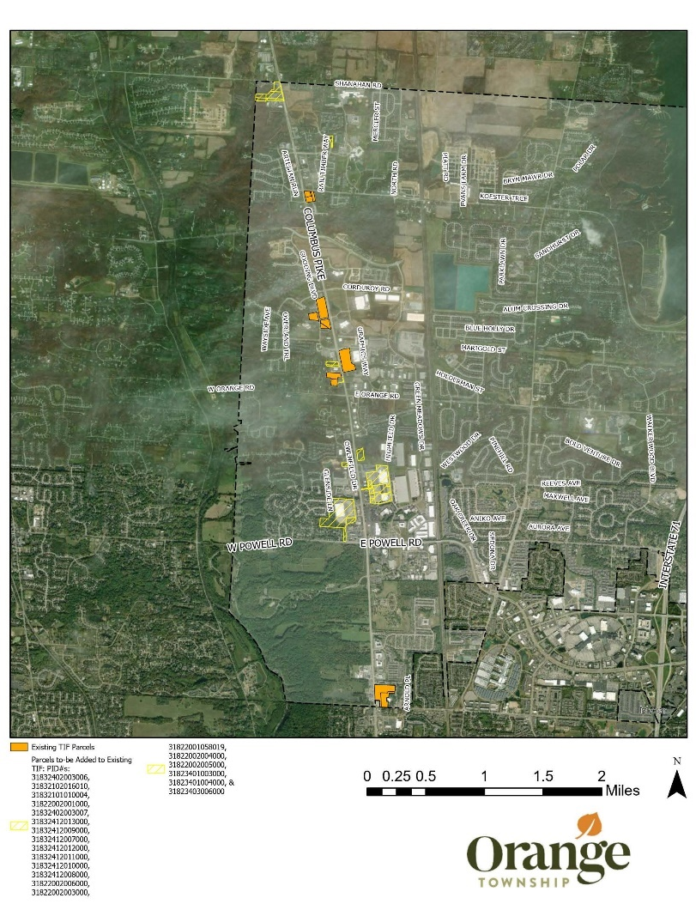
RES.25-098 A RESOLUTION AUTHORIZING THE ORANGE TOWNSHIP BOARD OF TRUSTEES TO ENTER INTO AN ENGAGEMENT LETTER WITH BRADLEY PAYNE LLC FOR MUNICIPAL ADVISORY SERVICES
Motion by Mr. Ringle
WHEREAS, the Board of Trustees of Orange Township, Delaware County, Ohio ("Board") recognizes the need for professional municipal advisory services to support the Township’s financial planning, capital project financing, and related advisory matters; and
WHEREAS, Bradley Payne LLC ("BP") is a registered Municipal Advisor with the Securities and Exchange Commission ("SEC") and the Municipal Securities Rulemaking Board ("MSRB") and has the expertise to provide such services to the Township; and
WHEREAS, the Township has received an engagement letter from BP, dated December 19, 2024, outlining the scope of services, fiduciary responsibilities, and compensation structure for municipal advisory services to be provided to the Township; and
WHEREAS, the Board finds it in the best interest of the Township to engage BP for municipal advisory services in accordance with the terms outlined in the engagement letter;
NOW, THEREFORE, BE IT RESOLVED by the Board of Trustees of Orange Township, Delaware County, Ohio, that:
- The Board hereby approves and authorizes the engagement of Bradley Payne LLC as the Township’s municipal advisor under the terms set forth in the engagement letter dated December 19, 2024.
- The Township Administrator, Michele Boni, is hereby authorized and directed to execute the engagement letter on behalf of Orange Township.
- The Fiscal Officer is authorized to take all necessary actions to process payments in accordance with the terms and conditions set forth in the engagement letter.
- This Resolution shall take effect immediately upon adoption.
Seconded by Mrs. Fouss
VOTE: Ringle – Yes Fouss – Yes Knapp – Yes

RES.25-099 ACCEPTING TRANSFER OF 132.17 HOURS OF SICK LEAVE TO THE CREDIT OF PROJECT MANAGER PHILIP MILLER
Mr. Ringle moved the adoption of the following resolution:

WHEREAS, Section 7.9 of the current Orange Township Handbook, new employees who transfer in from other governmental entities or military may, with proof of available balance from previous employer, transfer in up to 320 hours of sick leave that will be deposited in a “transferred sick leave” bank. This time may only be used when sick leave balance earned with the Township is at zero. Additionally, this transferred sick leave is not subject to being paid out upon separation from employment. Sick leave that was partially paid out at a former employer is not eligible to be transferred; and

WHEREAS, pursuant to such provision the Senior Human Resources Manager has presented the Board with a certification from Elizabeth Brown, Human Resources Administer for the Capital Square Review and Advisory Board of the State of Ohio, regarding Project Manager Philip Miller, indicating his service as Assistant Director and his accumulation of 132.17 hours of sick leave while employed by that public agency;

NOW THEREFORE BE IT RESOLVED that the transfer of 132.17 hours of sick leave to the credit of Project Manager Philip Miller is accepted and the Township Fiscal Officer is authorized and directed to integrate this transfer into this employee’s Township records.

Seconded by Ms. Knapp
VOTE: Ringle – Yes Fouss – Yes Knapp – Yes

RES.25-100 ENTER INTO EXECUTIVE SESSION
Motion by Mr. Ringle that the Board enter into Executive Session

- Pursuant to R.C. 121.22(G)(4) to review negotiations or bargaining sessions with public employees concerning their compensation or other terms and conditions of their employment.

Seconded by Mrs. Fouss
VOTE: Ringle – Yes Fouss – Yes Knapp – Yes

Those invited to attend Executive Session: All Trustees, Donna Batten, Michele Boni, Legal Counsel, Mike Kremnitzer, and Nathan McNeil.

RES.25-101 RETURN TO REGULAR SESSION
Mr. Ringle made a motion to return to regular session.

Seconded by Ms. Knapp
VOTE: Ringle – Yes Fouss – Yes Knapp – Yes

RES.25-102 AUTHORIZING THE ACCEPTANCE OF THE FACTFINDING REPORT AND RECOMMENDATION OF PHILLIP H. SHERIDAN, SERB CASE NO. 24-MED-06-0667 AND AUTHORIZING THE TOWNSHIP ADMINISTRATOR TO EXECUTE THE COLLECTIVE BARGAINING AGREEMENT
Mr. Ringle moved the adoption of the following resolution:

WHEREAS, the Township engaged in collective bargaining with the International Association of Firefighters Local 3816 for the purpose of negotiating a successor collective bargaining agreement, SERB Case No. 24-MED-06-0667;

WHEREAS, the Township and International Association of Firefighters Local 3816 reached impasse during bargaining and proceeded to a Factfinding hearing on or around January 16, 2025 before Factfinder Phillip H. Sheridan;

WHEREAS, Factfinder Phillip H. Sheridan issued a Factfinding Report and Recommendation on March 17, 2025;

WHEREAS, consistent with R.C. 4117.14, the Factfinding Report and Recommendation shall be submitted to the legislative body for a vote regarding its acceptance or rejection;

WHEREAS, pursuant to R.C. 4117.14, the Township has seven (7) days to vote regarding the acceptance or rejection of the Factfinding Report and Recommendation, or it shall be “deemed accepted.”

NOW THEREFORE, be it resolved by the Board of Trustees, of Orange Township, Delaware County, Ohio that:

Section 1. The Report and Recommendation of Factfinder Phillip H. Sheridan in SERB Case No. 24-MED-06-0667 in the matter involving Orange Township and the International Association of Firefighters, Local 3816 be accepted;

Section 2. The Orange Township Administrator shall take all appropriate steps to execute the collective bargaining agreement between Orange Township and the International Association of Firefighters Local 3816;

Section 3. All formal actions and deliberations of this Board concerning and/or relating to the adoption of this Resolution were conducted in a regular, open meeting as required by R.C. 121.11 and/or any other applicable legal requirements.

Seconded by Mrs. Fouss
VOTE: Ringle – Yes Fouss – Yes Knapp – Yes

CERTIFICATE
State of Ohio, Delaware County

I, the undersigned Township Fiscal Officer of Orange Township, Delaware County, Ohio, certify that the foregoing Resolution No. RES.25-102 is taken and copied from the record of proceedings of the Board, and that it has been compared by me with the Resolution on the record and is a true and accurate copy. Further, I certify that the adoption of such Resolution occurred in an open meeting held in compliance with R.C. § 121.22.

Date: March 19, 2025 __________________________________________
Donna Batten, Township Fiscal Officer
Orange Township, Delaware County, Ohio

RES.25-103 MEETING ADJOURNMENT
Motion by Mr. Ringle to adjourn.

Seconded by Ms. Knapp
VOTE: Ringle – Yes Fouss – Yes Knapp – Yes

Notice: Copies of documents referred to in this journal can be obtained by contacting the Orange Township Administrator.

_______________________________________
Michael Ringle
Chair

______________________________________
Erica Fouss
Vice Chair

_______________________________________
Lisa Knapp
Trustee

Attest: ___________________________
Donna Batten
Fiscal Officer

